**C968 Task 1**

GUI Mock-Up

1. "Main" screen

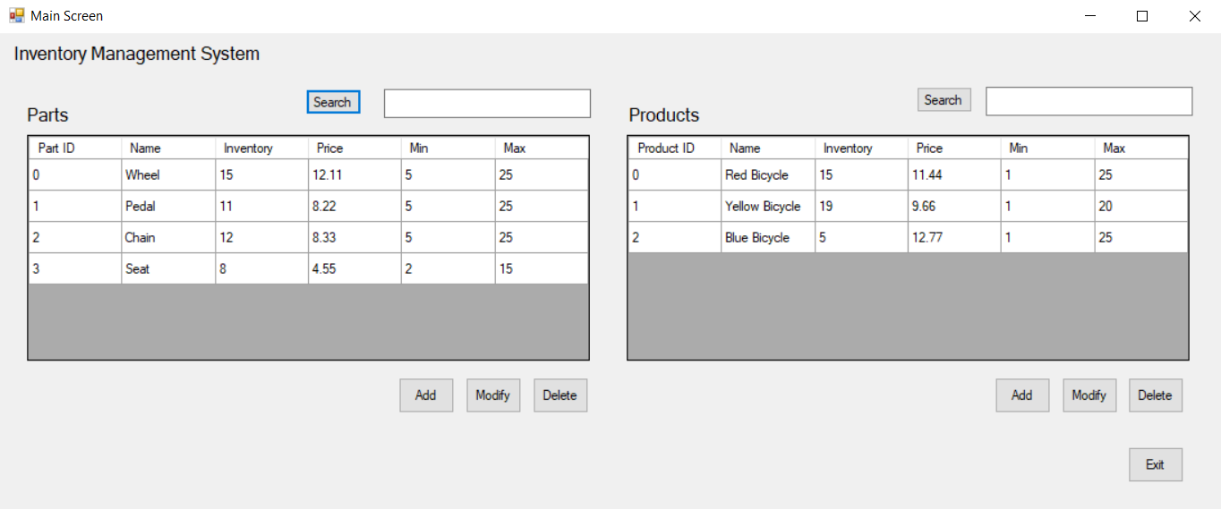

The "Main Screen" displays the current table of parts and the current table of products. It allows the user to initiate an add or modify for the parts or products. It also allows the user to delete a part or a product. It allows a user to search for particular parts or products. "Exit" shuts down the app.

1. "Add Part" screen

A screenshot shows two options for adding a part to the parts table. 

On the left, the Add Part radio button for "In House" is selected. There is an arrow pointing to this. There is another arrow pointing to Machine ID. All fields are highlighted red. 

On the right, the Add Part radio button for "Outsourced" is selected. There is an arrow pointing to this. There is another arrow pointing to Company Name. All form fields are highlighted red. 

The user uses this "Add Part" screen to add a part to the parts list by supplying information about the part and then selecting "Save." After a successful "Save," the user is returned to the main screen. If the user selects "Cancel," no part will be added to the parts list, and the screen will revert to the main screen.

The user has the option to select "In-House" or "Outsourced" to categorize the part. If the user selects "Outsourced," the "Company Name" field is available. If the user selects "In-House," the "Machine ID" field is available. This is highlighted in the figures using the arrows.

The "Inventory" field contains how many of these parts the company currently has available. The "Min" field contains the minimum number of these parts allowed. The "Max" field contains the maximum number of these parts allowed. The value of "Inventory" must be an integer between the values in "Min" and "Max." You do not need to dynamically manage (decrement/increment) the value in "Inventory" as you add or delete parts in the associated parts list of a product.

1. "Modify Part" screen

A screenshot shows two options for adding a part to the parts table. 

On the left, the Add Part radio button for "In House" is selected. There is an arrow pointing to this. There is another arrow pointing to Machine ID. All fields are filled in and the Save button is highlighted blue in the bottom right corner.

On the right, the Add Part radio button for "Outsourced" is selected. There is an arrow pointing to this. There is another arrow pointing to Company Name. All form fields are filled in with information. 

The user uses this "Modify Part" screen to modify a part selected by the user that is already in the parts list by supplying information about the part and then selecting "Save." After a successful "Save," the user is returned to the main screen. If the user selects "Cancel," no modifications to the part in the parts list will be made, and the screen will revert to the main screen.

As in the "Add Part" form, the "Modify Part" form allows the user to select "In-House" or "Outsourced" to categorize the part. The "Modify Part" screen has the same functionality as the "Add Part" screen; however, the "Modify Part" screen text boxes are populated with data from an already existing part that was previously selected by the user.

1. "Add Product" screen

A screenshot shows the Add Product page. On the left, there are form fields that are highlighted red. 

On the right, there are two tables. The top table is labeled, "All candidate parts." It has a search button and text field above it and an Add button below it. The bottom table is labeled, "Parts Associated with this Product." 

There are three buttons in the bottom right corner labeled, "Delete," "Save", and "Cancel." The Save button is grayed out.

The user uses this "Add Product" screen to add a product to the products list by supplying information about the product and then selecting "Save." After a successful "Save," the user is returned to the main screen. If the user selects "Cancel," no product will be added to the products list, and the screen will revert to the main screen.

The "Add Product" screen allows the user to select and add parts from the upper grid to the associated parts list in the lower grid. When added, the selected part is associated with that product and appears in the lower grid. It is not removed from the upper grid. The user can select and delete parts from the lower grid, effectively disassociating the part from that product.

The upper grid represents all candidate parts and can be labeled as such (see image). The lower grid represents the parts associated with the product and can be labeled as such (see image).

The "Inventory" field contains how many of these products the company currently has available. The "Min" field contains the minimum number of these products allowed. The "Max" field contains the maximum number of these products allowed. The value of "Inventory" must be an integer between the values in "Min" and "Max."

1. "Modify Product" screen

A screenshot shows the Add Product page. On the left, there are form fields that are filled in with pertinent information. 

On the right, there are two tables. The top table is labeled, "All candidate parts." It has a search button and text field above it and an Add button below it. The bottom table is labeled, "Parts Associated with this Product." 

There are three buttons in the bottom right corner labeled, "Delete," "Save", and "Cancel."

The user uses this "Modify Product" screen to modify a product selected by the user that is already in the products list by supplying information about the product and then selecting "Save". After a successful "Save," the user is returned to the main screen. If the user selects "Cancel," no modifications to the product in the products list will be made, and the screen will revert to the main screen.

The "Modify Product" screen has the same functionality as the "Add Product" screen; however, the "Modify Product" screen parts and fields are populated with data from an already existing product that was previously selected by the user.

It is acceptable, but not required, for the app to use a single form (C# file) for both "Add Part" and "Modify Part" screens. It is acceptable, but not required, for the app to use a single form (C# file) for both "Add Product" and "Modify Product" screens. Consult with your instructor if this is unclear or if you need further explanation.

The ID fields for both the “Parts” and “Products” should display auto-generated (unique) numbers. These ID fields should not allow user modifications.

Watch an example [video of a PA solution with the GUI in action](https://wgu.hosted.panopto.com/Panopto/Pages/Viewer.aspx?id=d6a807b5-919e-4d42-bb88-a922012975de). This is just an example. It represents one of many possible approaches to a solution.

Note: Though the demo shows a product is not able to be saved without a part, this is allowed.